VANASTHALI PUBLIC SCHOOL

Computer Science Project File

Q.1 Program to calculate simple interest using a function interest() that can receive principal amount , time and rate and returns calculated simple interest. Do specify default values for rate and time as 10% and 2 years respectively.

CODE:-
def interest(principal,time=2,rate=0.10):
return principal*rate*time
#__main__
Prin=float(input('Enter principal amount:'))
print("Simple interest with default ROI and time value is:")
Si1=interest(Prin)
print("Rs.",Si1)
Roi=float(input("Enter rate of interest:"))
time=int(input("Enter time in years:"))
print("Simple interest with your provided ROI and time value is:")
Si2=interest(Prin,time,Roi)
print("Rs.",Si2)

OUTPUT:-
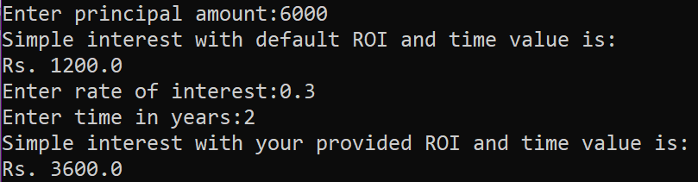
Q.2 Given a dictionary with values list, extract key whose value has most unique values.
CODE:-

test_dict = {"Gfg" : [5, 7, 5, 4, 5],
"HANG" : [6, 7, 4, 3, 3],
"Best" : [9, 9, 6, 5, 5]}
print("The original dictionary is : " + str(test_dict))
max_val=0
max_key=None
for sub in test_dict:
if len(set(test_dict[sub]))>max_val:
max_val=len(set(test_dict[sub]))
max_key=sub
print("Key with maximum unique values : "+ str(max_key))
OUTPUT:

Q.3 Write a python program that displays a first three rows fetched from student table of MySQL database “supermarket”.

CODE:-

import mysql.connector as con
c=con.connect(host="localhost",user="root",passwd="123456",database="supermarket")
if c.is_connected() == False:
print('Error connecting to MySQL database')
crsr=c.cursor()
crsr.execute("select * from product")
data=crsr.fetchmany(3)
count=crsr.rowcount
for row in data :
print(row)
c.close()
OUTPUT:-

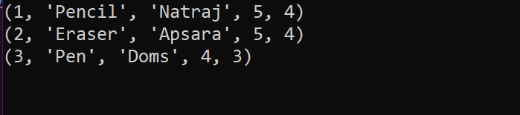

Q.4 Define a function having a variable as its argument and check whether the string is palindrome or not.

CODE:-

def pallindrome(string):
newstr=""
for w in range (-1,-len(string)-1,-1):
newstr=newstr+string[w]
if newstr==string:
print(string,"is a pallindrome")
else:
print(string,"is not a pallindrome")
var=input("Enter String:")
pallindrome(var)
OUTPUT:-
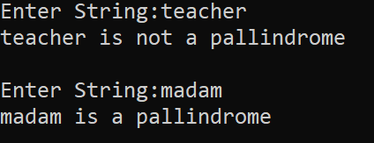

Q.5 Define a function to input a number and check whether the given number is Armstrong number or not .
(Note: If a 3 digit number is equal to the sum of the cubes of its each digit , then it is an Armstrong number )

CODE:-

def armstrong():
num=int(input("Enter a 3 digit number:"))
su=0
for w in str(num):
su=su+int(w)**3
if num==su:
print(num,"is an Armstrong number")
else:
print(num,"is not an Armstrong number")
armstrong()
OUTPUT:-
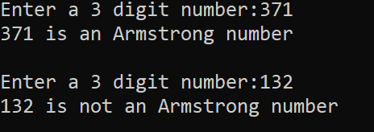

Q.6 Write a program to print the following pattern :

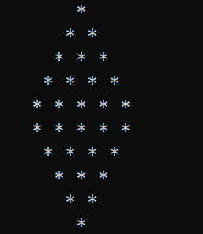
CODE:-

n=5 #for number of lines
# upper half
for i in range(1,n+1):
print(" "," "*(n-i)+"* "*i)
# lower half
for i in range(n,0,-1):
print(" "," "*(n-i)+"* "*i)

Q.7 Write a program to build a table named as stationary with attributes Id, name, price, company Id is primary key Add records until user want and display same
CODE:-
z=0
import mysql.connector as con
while z==0:
try:
pswd=input("Enter Password:")
dbobj=con.connect(host="localhost",user="root",password=pswd,charset="utf8")
z=1
except:
print("Wrong Password")
crsr=dbobj.cursor()
def db():
crsr.execute("CREATE DATABASE IF NOT EXISTS SAMPLE;")
crsr.execute("commit")
crsr.execute("USE SAMPLE;")
crsr.execute("commit")
crsr.execute("CREATE TABLE IF NOT EXISTS STATIONARY(Id int Primary key,Name char(20),Price int,Company char(20));")
crsr.execute("commit")
db()

def que():
y=0
print("Enter ID as 0 to exit")
while y==0:
try:
i=int(input("Enter ID:"))
if i==0:
y=1
else:
name=input("Enter Name:")
price=int(input("Enter Price:"))
company=input("Enter Company:")
lst=(str(i),name,str(price),company)
print(lst)
confirm=input("Confirm(Y/N):")
if confirm=="Y" or "y":
crsr.execute("INSERT INTO STATIONARY VALUES ('{}','{}','{}','{}')".format(i,name,price,company))
crsr.execute("commit")
except:
print("Some ERROR")

def dis():
print()
print("-"*85)
crsr.execute("DESC STATIONARY;")
recs=crsr.fetchall()
print("%3s %-10s %-5s %5s"%(recs[0][0],recs[1][0],recs[2][0],recs[3][0]))
crsr.execute("select * from STATIONARY;")
recs=crsr.fetchall()
for rec in recs:
print("%3s %-10s %5s %5s"%(rec[0],rec[1],rec[2],rec[3]))
que()
dis()

OUTPUT:- 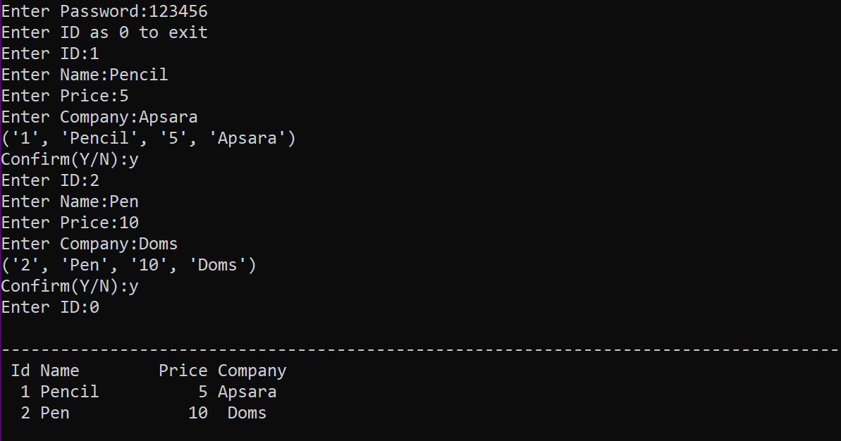

Q.8 Program to find frequencies of all elements of a list .Also , print the list of unique elements in the list and duplicate elements in the given list.

CODE:-
lst=eval(input("Enter list:"))
lstc=list(lst)
uniq=[]
dupl=[]
for element in lst:
c=0
for w in lst:
if element==w:
c=c+1
if c==1:
uniq.append(element)
print('Element',element,'frequency',c)
for q in lstc:
if lst.count(q)==1:
pass
else:
for w in range(len(lstc)-1):
if lstc[w]==q:
print('Element',q,'frequency',lstc.count(q))
dupl.append(q)
lstc.pop(w)
print('Original List:',list(lst))
print('Unique Elements List',uniq)
print('Duplicates Elements List',dupl)

OUTPUT:-
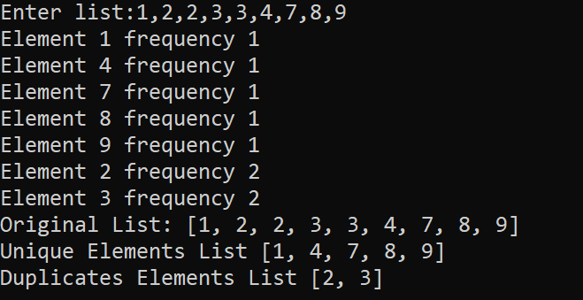
Q.34 Given the following tables for a database LIBRARY :
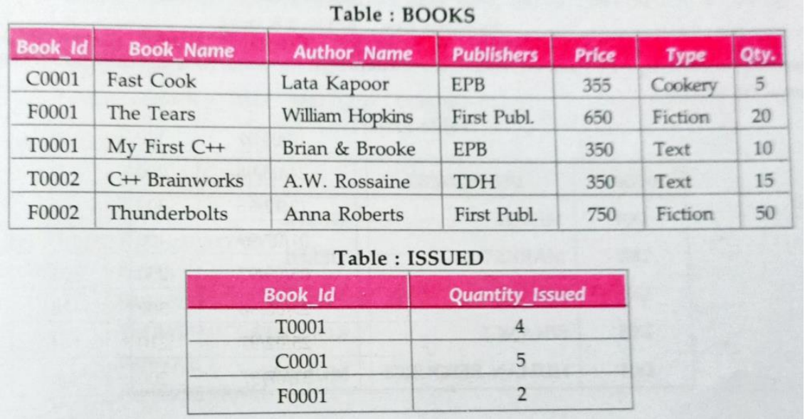

Write SQL queries for (a) to (f):

- To show Book name , Author name and Price of books of First Publc publishers.

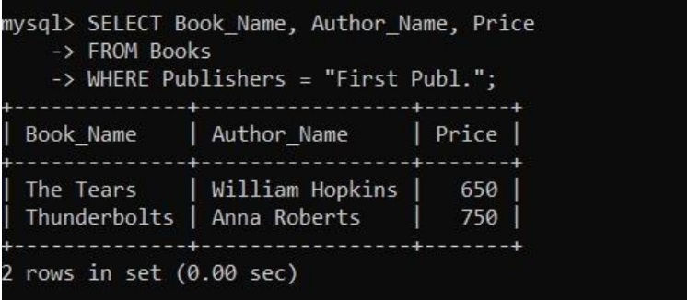

- To list the names from books of text type.

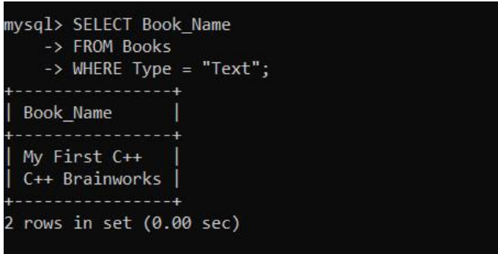

- To display the names and prices from books in ascending order of their price.

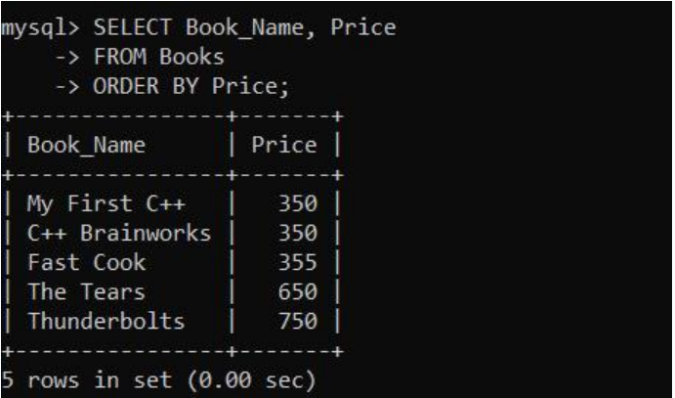

- To increase the price of all books of EPB Publishers by 50 .

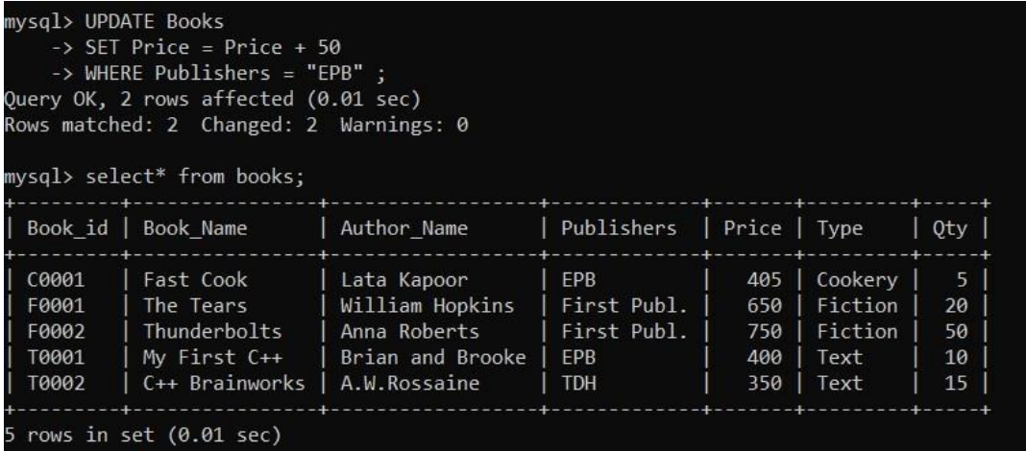

- To display the Book_id,Book_Name and Quantity_Issued for all books which have been issued.(The query will require contents from both the tables.)

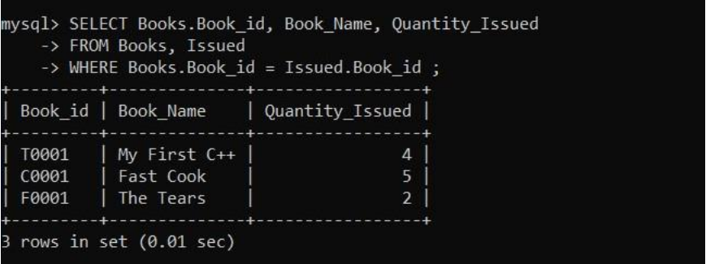

- To insert a new row in the table Issued having the following data : "F0003",1

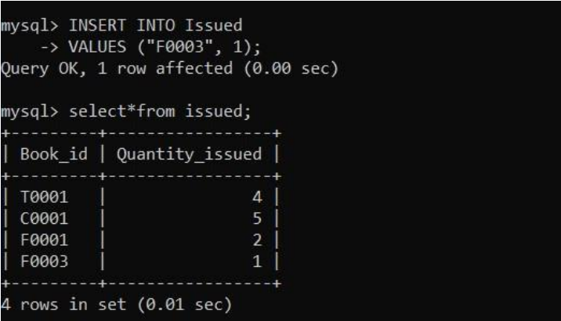

Q.10 Define a function to check if the elements in the first half of a tuple are sorted in ascending order or not.

CODE:-

tup = eval(input("Enter a tuple:"))
ln = len(tup)
mid = ln//2
if ln % 2 == 1:
mid = mid + 1
half = tup[:mid]
if sorted(half) == list(tup[:mid]):
print("First half is sorted")
else:
print("First half is not sorted" def tuplehalf():
tup=eval(input("Enter a tuple:"))
ln=len(tup)
mid=ln//2
if ln%2==1:
mid=mid+1
half=tup[:mid]
if sorted(half)==list(tup[:mid]):
print("First half is sorted")
else:
print("First half is not sorted")

tuplehalf()

OUTPUT:-
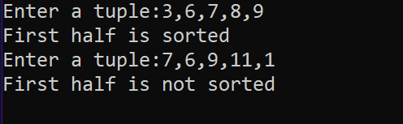
Q.11 Program to count the frequency of a list of elements using a dictionary.

CODE:-

sentence="This is a super idea This idea will change the idea of learning"
words=sentence.split()
d={}
for one in words:
key=one
if key not in d:
count=words.count(key)
d[key]=count
print("Counting frequencies in list \n",words)
for w in d:
print(" "+w.ljust(15),str(d[w]).ljust(3))
OUTPUT:-
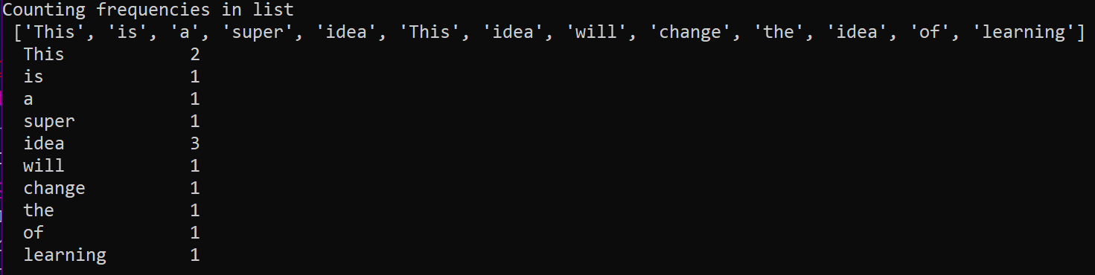

Q.12 Write a program to create a dictionary with the roll number, name and marks of n students in a class and display the names of students who have marks above 75.

CODE:-
n=int(input("How many Students?"))
stu={}
for i in range(1,n+1):
print()
print("Enter details of student",(i))
rollno=int(input("Roll number:"))
name=input("Name:")
marks=float(input("Marks:"))
d={"Rollno" :rollno,"Name":name,"Marks": marks}
key="Stu"+str(i)
stu[key]=d
print("Students with marks > 75 are:")
for i in range(1,n+1):
key="Stu"+str(i)
if stu[key]["Marks"]>=75:
print(" RollNo".ljust(8),str(stu[key]["Rollno"]).ljust(3)," Name".ljust(6),str(stu[key]["Name"]).ljust(20)," Marks".ljust(7),str(stu[key]["Marks"]).ljust(20))

OUTPUT:-
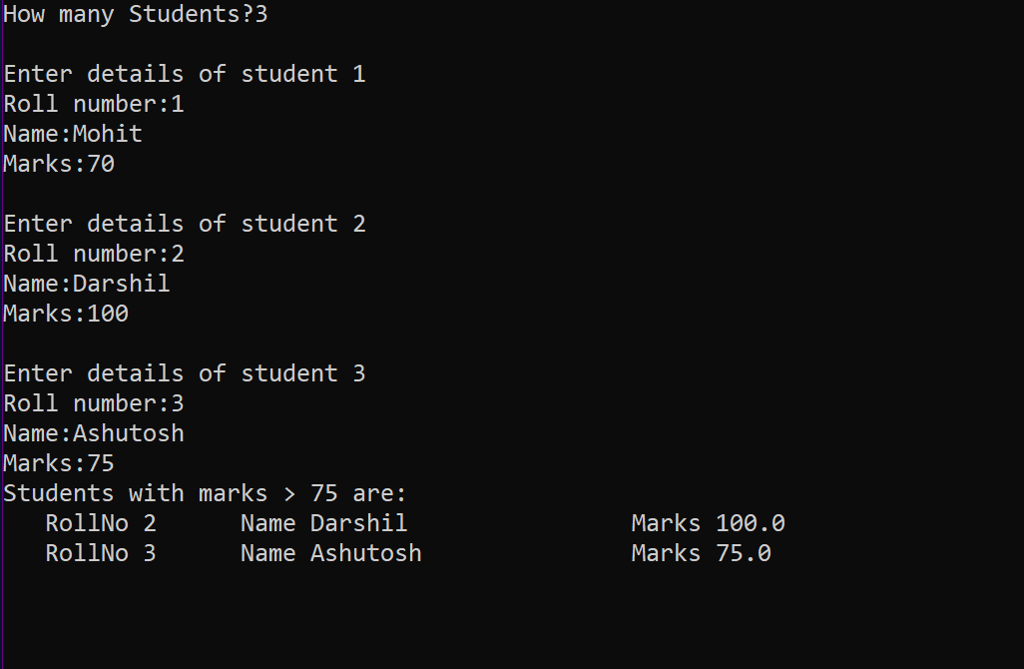

Q.13 Read a text file x.txt and built y.txt that should be reverse of x. txt
CODE:-

def reverse(x,y):
fx=open(x,"r")
fy=open(y,"w+")
k=fx.readlines()
for w in range(-1,-len(k)-1,-1):
x=k[w].rstrip("\n")
line=x
newlin=""
for i in range (-1,-len(line)-1,-1):
newlin=newlin+line[i]
print(newlin)
fy.write(newlin+"\n")
reverse("Abc.txt","NewAbc.txt")
OUTPUT:-
Q.14 Program to sort a sequence using insertion sort.

CODE:-

aList = [15,6,13,22,3,52,2]
print("Original list is:",aList)
for i in range(1,len(aList)):
key=aList[i]
j=i-1
while j>=0 and key<aList[j]:
aList[j+1]=aList[j]
j=j-1
else:
aList[j+1] = key
print("List after sorting:",aList)
OUTPUT:-
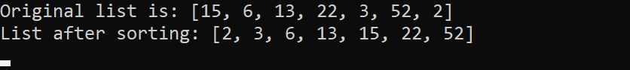

Q.15 Program to sort a list using bubble sort.

CODE:-

alist = [15,6,13,22,3,52,2]
print("original list is:",alist)
n=len(alist)
for i in range(n):
for j in range(0,n-i-1):
if alist[j]>alist[j+1]:
alist[j],alist[j+1]=alist[j+1],alist[j]
print("list after sorting:",alist)
OUTPUT:-
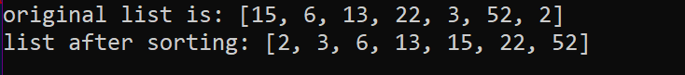

Q.16 Write a program that inputs main string and then creates an encrypted string by embedding a short symbol based string after each character . The program should also be able to produce the decrypted string from encrypted string.

CODE:-

def encrypt(sttr,enkey):
return enkey.join(sttr)
def decrypt(sttr,enkey):
return sttr.split(enkey)
#-main
mainstring = input("enter main string:")
encryptstr = input("enter encryption key:")
enstr=encrypt(mainstring,encryptstr)
delst=decrypt(enstr,encryptstr)
destr="".join(delst)
print("the encrypted string is",enstr)
print("string after dcryption is:",destr)
OUTPUT:-
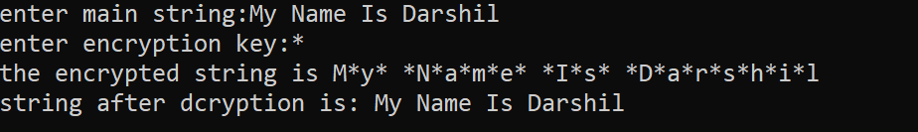

Q.17 Define a function having a text file name as it's argument. The function should return a Dictionary having key as line number of text file and values list of two integers [number of upper case alphabets and number of lower case alphabet ] in each line.

CODE:-

def fx(file):
z=0
di={}
f=open(file,"r")
lst=f.readlines()
for line in lst:
z=z+1
uc=0
lc=0
for word in line:
if word.isupper():
uc=uc+1
elif word.islower():
lc=lc+1
di[z]=[lc,uc]
return di

y=fx("Abc.txt")
print(y)

OUTPUT:-
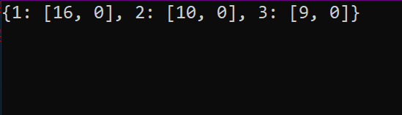

Q.18 Write a program to read a text file line by line and display each word separated by a ‘#’.

CODE:-

myfile=open("answer.txt","r")
line=" "
while line:
line=myfile.readline()
for word in line.split():
print(word,end='#')
myfile.close()

FILE CONTENTS
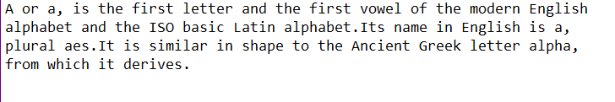
OUTPUT:-

Q.19 Write a program to read a text file and display the count of vowels and consonants in the file.

CODE:-

myfile = open("answer.txt","r")
ch=" "
vcount=0
ccount=0
while ch:
ch=myfile.read(1)
if ch in['a','A','e','E','i','I','o','O','u','U']:
vcount=vcount+1
else:
ccount=ccount +1
print("vowels in the file:",vcount)
print("consonants in the file:",ccount)
myfile.close()
FILE CONTENTS
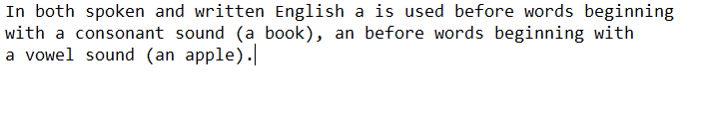
OUTPUT:-

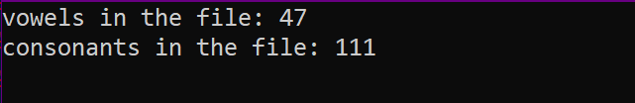

Q.20 Write a program to get student data(roll no. , name and marks) from user and write onto a binary file. The program should be able to get data from the user and write onto the file as long as the user wants.

CODE:-

import pickle
stu={}
stufile=open('Stu.dat', 'wb')
ans='y'
while ans=='y' or ans='Y':
rno=int(input("Enter roll number : "))
name=input("Enter name :")
marks=float(input("Enter marks : "))
stu['Rollno']=rno
stu['Name']=name
stu['Marks']=marks
pickle.dump(stu, stufile)
ans=input("Want to enter more records? (y/n)...")
stufile.close()
OUTPUT:-
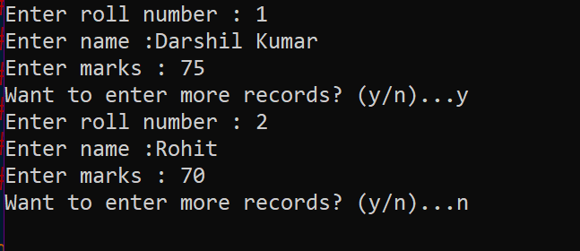
Q.21 Write a program to append student records to file created in previous program, by getting data from user.

CODE:-

import pickle
stu={ }
stufile=open('Stu.dat', 'ab')
ans='y'
while ans=='y' or ans=='Y':
rno=int(input("Enter roll number :"))
name=input("Enter name :")
marks=float( input("Enter marks: "))
stu['Rollno']=rno
stu['Name']=name
stu['Marks']=marks
conf=input('Confirm(y/n):')
if conf=='Y' or conf=='Y':
pickle.dump(stu,stufile)
ans = input("Want to append more records? (y/n)...")
stufile.close()

OUTPUT:-
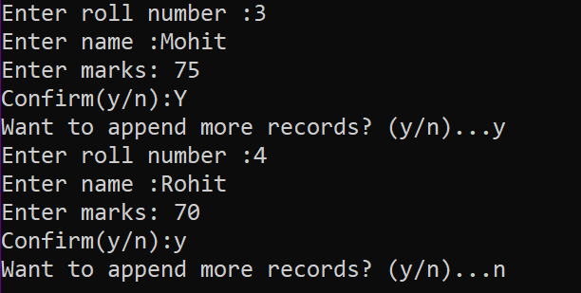
Q.22 Write a program to open file Stu.dat and search for records with roll numbers as 46 or 48 . If found display the records.
CODE:-

import pickle
stu={}
found=False
fin=open('Stu.dat', 'rb')
searchkeys=[46, 48]
try:
print("Searching in File Stu.dat ...")
while True :
stu=pickle.load(fin)
if stu['Rollno'] in searchkeys:
print(stu)
found=True
except EOFError:
if found==False :
print("No such records found in the file")
else:
print("Search successful.")
fin.close()
OUTPUT:-
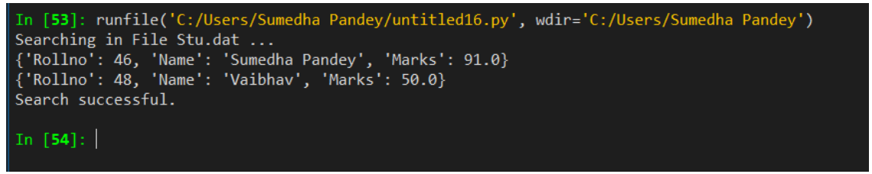

Q.23 Python program to implement stack operations.

CODE:-

def push(s,x):
global top
s.append(x)
top=len(s)-1

def pop(s):
global top
if len(s)==0:
print("Underflow")
else:
x=s.pop()
print("poped ",x)
if len(s)==0:
top=None
else:
top=len(s)-1

def display(s):
global top
if len(s)==0:
print("stack is empty")
else:
print("Stack elements....")
for a in range (top,-1,-1):
print(s[a])

stack=[]
top=None
while True:
print("\nStack operations")
print("1.Push")
print("2.Pop")
print("3.Display")
print("4.Exit")
print('top is',top)
ch=int(input("Enter choice : "))
if ch==1:
item=int(input("Enter data : "))
push(stack,item)
elif ch==2:
pop(stack)
elif ch==3:
display(stack)
else:
break
OUTPUT:-
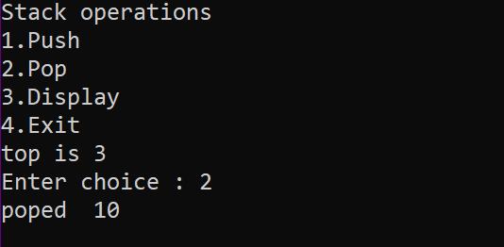
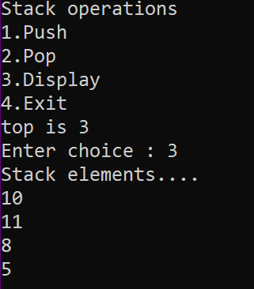

Q24. Define a function reading few lines from the user in a list until an empty line is given as input and count the lines contains a word cat in it.
def fx():
k=[]
while True:
x=input("Enter a Line:")
if x=="":
break
else:
k.append(x)
print(k)
c=0
for w in k:
y=w.split()
if "cat" in y:
c=c+1
print("Count of lines containing cat",c)
fx()

OUTPUT:-
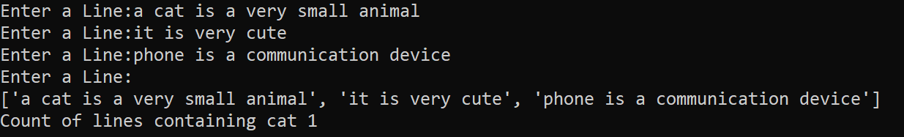

Q.25 Write a program to read following details of sport’s performance (sport , competitions, prizes-won) of your school and store into a csv file delimited with tab character .

CODE:-

import csv
fh=open("Sport.csv","w")
writer=csv.writer(fh,delimiter='\t')
writer.writerow(['Sport','Competitions','Prizes won'])
ans='y'
i=1
while ans=='y':
print("Record", i)
sport=input("Sport name:")
comp=int(input("No. of competitions participated :"))
prizes=int(input("Prizes won:"))
srec=[sport,comp,prizes] # create sequence of user data
writer.writerow(srec)
i=1+1
ans=input("Want to enter more records? (y/n)..")
fh.close()

OUTPUT:-
